Window to Bolivia

Providing A Glimpse Into Another Part Of Our World
Bolivian Youth Ministries Jonathan and Linda Baker
** December 2006 **

The
May God enable us to have a single eye and a simple heart, desiring to please God, to do good to our fellow creatures and to testify our gratitude to our adorable Redeemer.

PRAYER
* Please pray that the Lord would constantly provide wisdom in making decisions. From future direction to simply understanding the individual needs of each girl; our desire is to walk in His will.

* As the New Year starts, we will be looking for people who want to work in this ministry. We need discernment in bringing on the best people for the work that God is completing here.

PRAISE
* The school year has ended and we thank God for His goodness in helping the girls excel in their studies. We also thank the Lord that most of the girls have the desire to do well.

* We had several girls come to us from difficult situations at the beginning of 2006. The start was a bit rocky for all of us but we praise God for His goodness in settling them in and getting them used to some boundaries in their lives.

* We thank God for the folks He has brought into our lives this past year. There have been some incredible blessings from new friends.

The Year Girls in Review

Life is full of changes and this year has not been an exception to this rule. The good news is that we have been so busy this year that we didn’t notice what was happening and the changes came fairly easy.

One of these changes has been the shift in where the girls come. In the beginning nearly all the girls were from the jail system. Now, we are seeing more of a need for truly orphaned, abandoned, and neglected children. We believe that God is working through this ministry to reach the ones He has chosen.

There are now three ‘classes’ of girls here:

From the jail system (8); the mother and/or father is in jail at the moment and it is dangerous and unhealthy for the child to live with them. A relationship is maintained with the parent in the hope that one day the child will return to the parent's custody.

Orphaned (11); the child's parents have died or the child was abandoned and the location of parents or relatives is unknown. There is no contact with any relative and we assume after a year+ that there will be none in the future.

Abandoned (6); the child was abandoned into our care and some information regarding the parents is available. Many were removed from abusive situation; some have visitors.

It’s difficult to imagine what it’s like to grow up in an orphanage so we do our best to provide a home-like atmosphere for the girls in which they will sense love, belonging and a family bond. For many, this is their family as there is nowhere else to go; they will be with us until they reach adulthood or independence. By the grace of God, His Word is being deeply rooted in their hearts and will stay with them for the rest of their lives.

To all of you who support this ministry through your prayers and finances we want to say ¡THANKS! It’s been a great year and we trust that in 2007 God will continue to be glorified through His work here as lives are touched by His love.

Year End Wants, Needs and Desires

A few people have written asking what specific needs we have. It’s always easier to give when the focus is on a tangible need or item; we understand that. It’s just that it’s quite difficult for us to ask—so we won’t. We’ll just mention a couple items:

Bed/Wardrobe Combos. We need 4 more of these. Designed (by Jon) and made (by Teo) in Bolivia, these make 3 girls per small room possible. Cost $280 each.

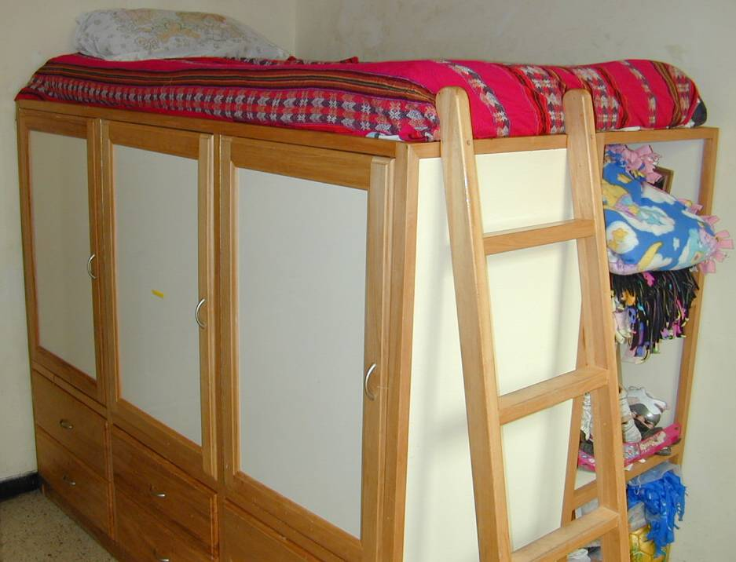

Student Center Tables and Benches. We need 2 more tables and 4 benches. Cost is about $100/table and $60/bench.

School Materials. School starts in February and we are required to provide books, materials and uniforms for 22 girls. The cost is about $50 per student.

Park Improvements. We’d like to put a small roof over the park ‘towers’ and install a slide. Cost is about $150 for lumber and $75 for the slide.

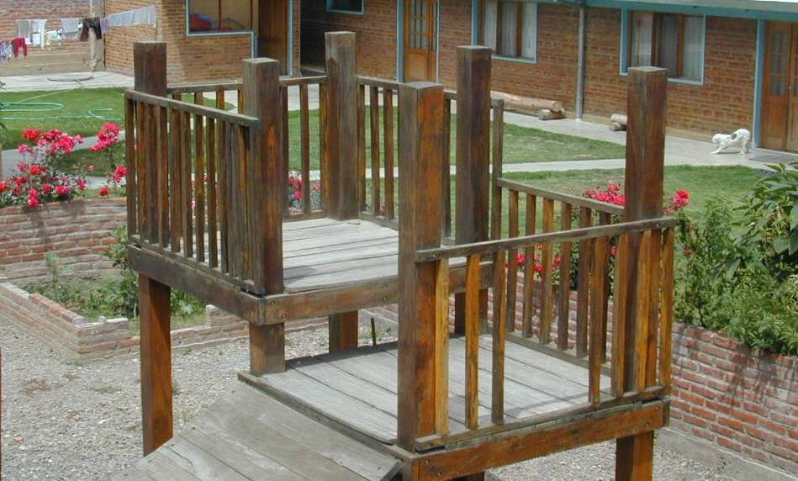

If you are interested in giving to these or other projects, you can send funds to Community Chapel with a note stating the purpose. We’ll make sure it’s used for that purpose.
“Nothing matters more than what God has thought and spoken about everything, especially about Himself.”

Jonathan & Linda Baker
Rosa and Joanna
(Bolivia)
Ryan, Joshua and Zachary
(US)
Kyle, Diana and Todd
(US)

26987 Fern Ridge Road
Sweet Home, OR 97386

Misión Niñez Boliviana
Cajón 3471
Cochabamba
Bolivia

www.BYMinistries.org

BYM@BYMinistries.org

Please look at our website for lots of good pix and information.
Email us any time!
¡MUSIC!

What if the armies of the Lord Picked up and dusted off their swords

Vowed to set the captives free And not let Satan have one more

What if the Church, for heaven's sake Finally stepped up to the plate Took a stand upon God's promise And stormed Hell's rusty gates

What if His people prayed And those who bear His name Would humbly seek His face And turn from their own way

And what would happen if we prayed For those raised up to lead the way Then maybe kids in school could pray And unborn children see the light of day

What if the life that we pursue Came from a hunger for the truth What if the family turned to Jesus Stopped asking Oprah what to do

He said that they would hear His promise has been made

He'll answer loud and clear If only we would pray

What if His people prayed And those who bear His name Would humbly seek His face And turn from their own way

If my people called by My name If they'll humble themselves and pray

Casting Crowns
Bolivian Youth Ministries
Sweet Home Community Chapel

42250 Ames Creek Road
Sweet Home, OR 97386
Erika and Carla taking a Sunday afternoon ride
Pequi, The Queen of Tricycling
Nicole was thrilled with her birthday presents
Alejandra and Carla Lorena
‘hanging out’
The whole group at Ryan’s going away party
Three in a Tree
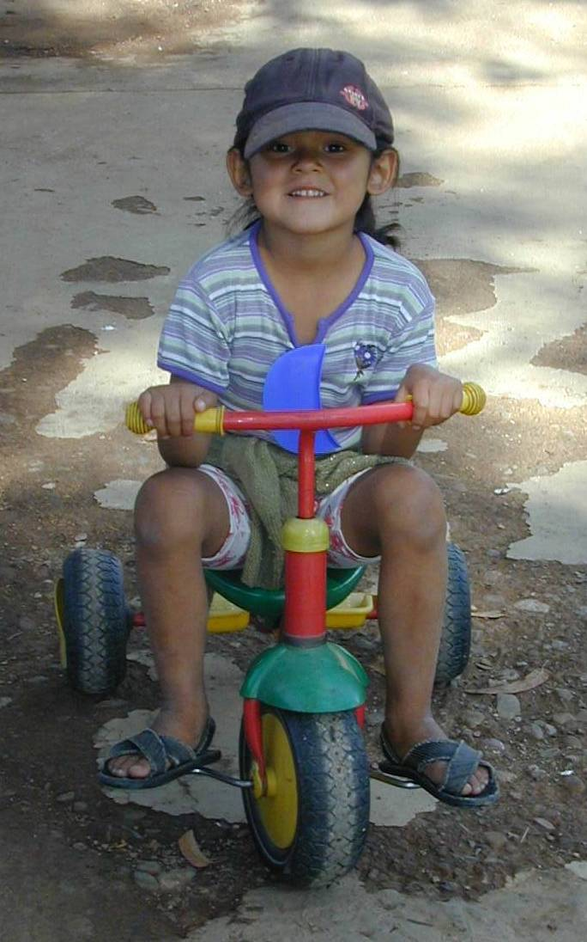
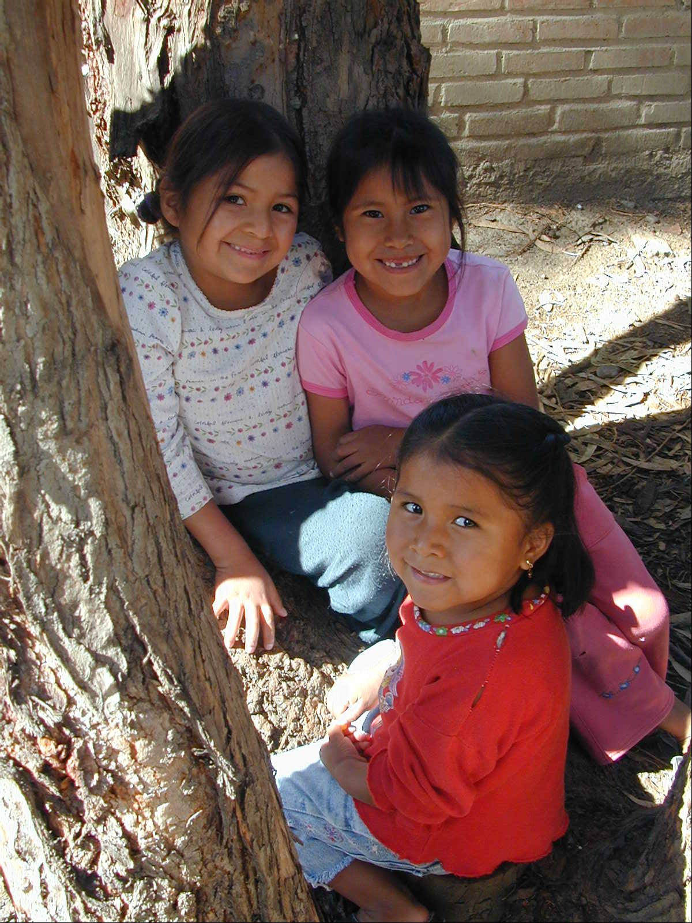
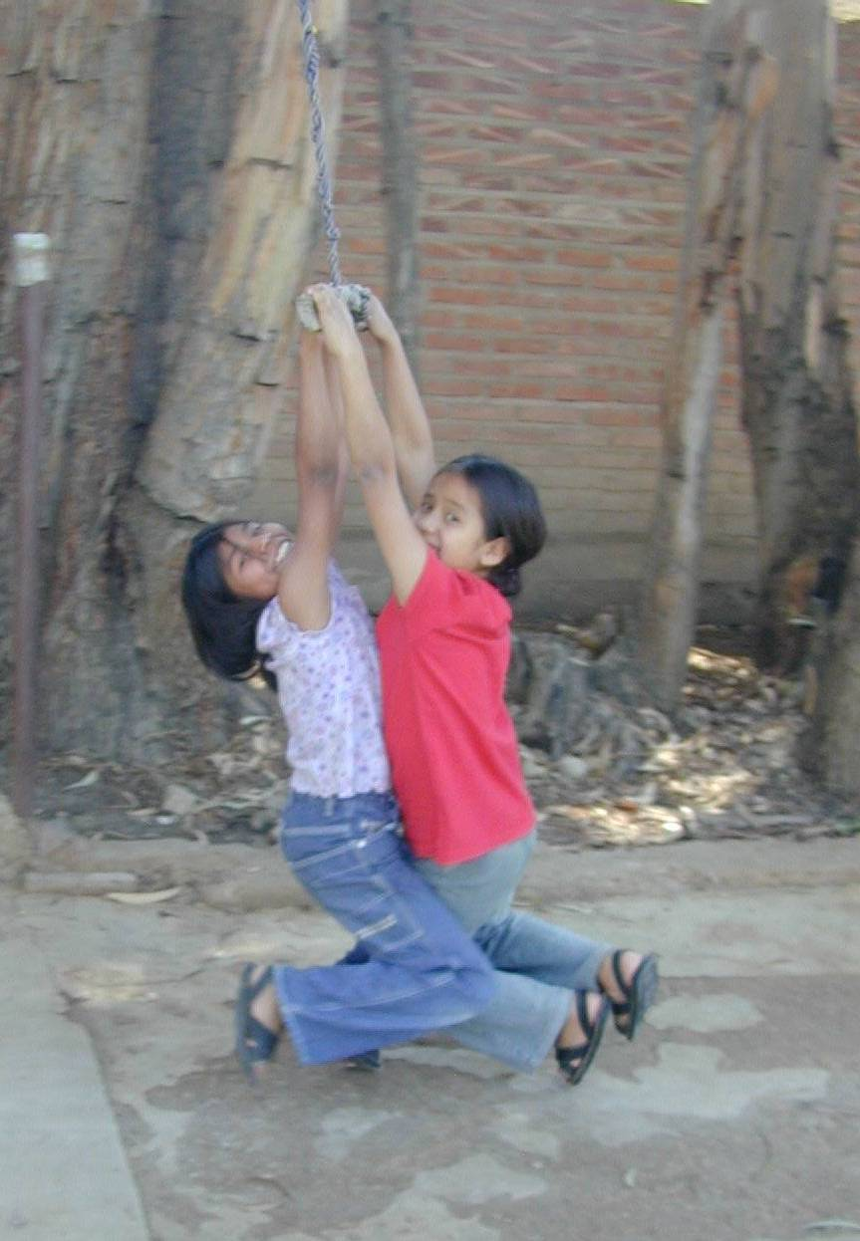
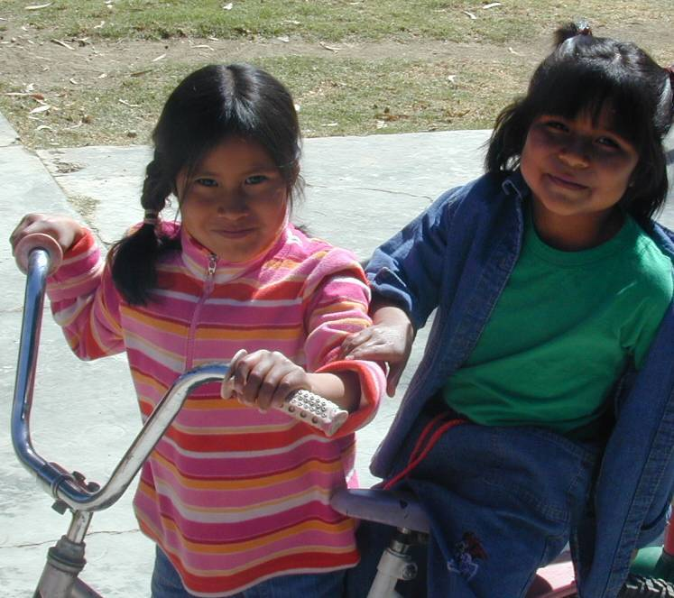
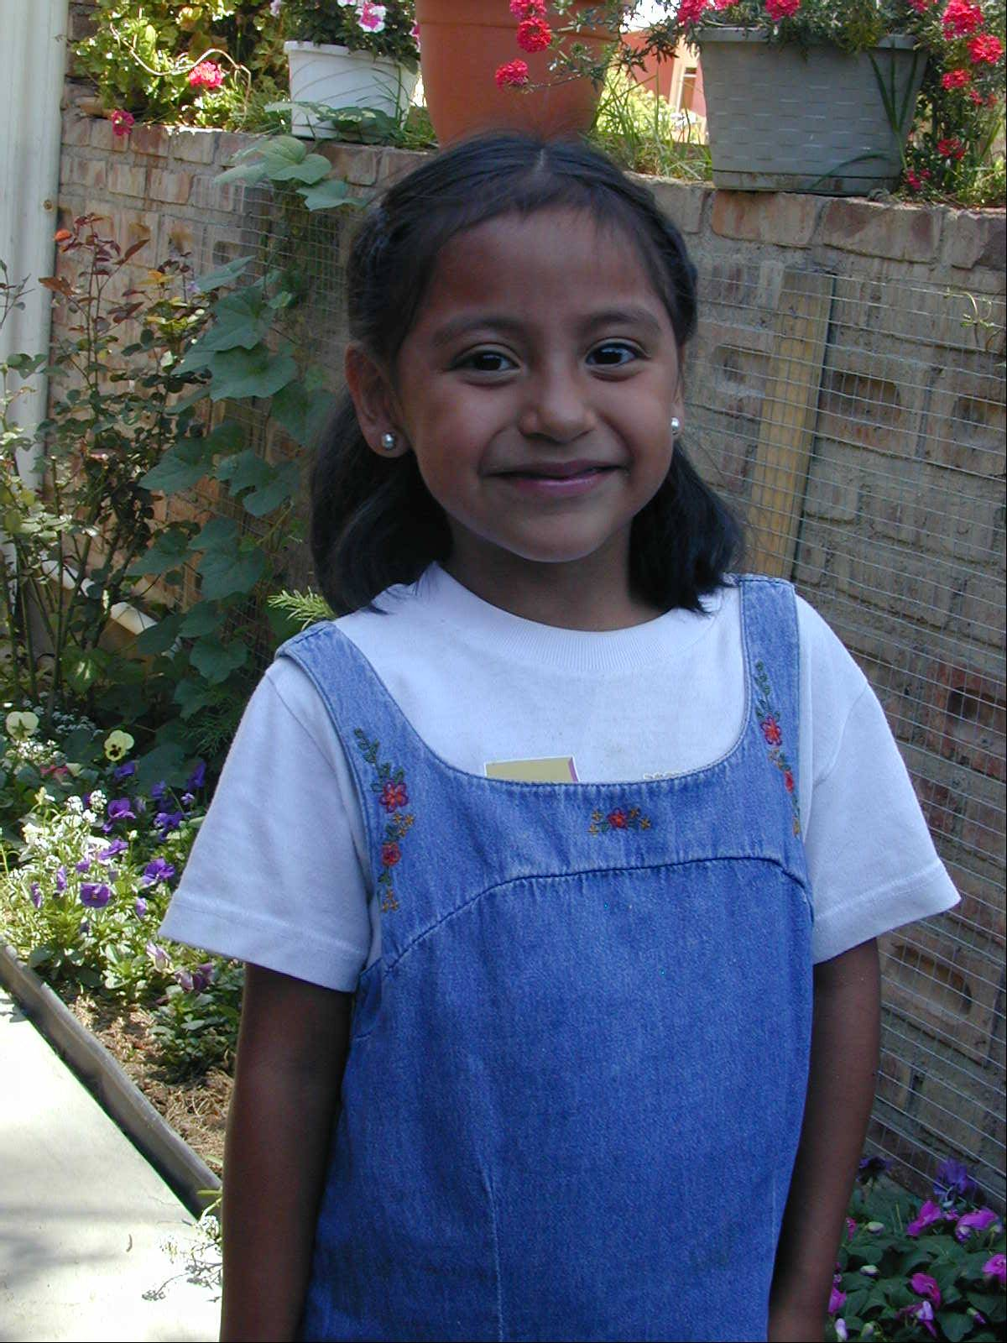
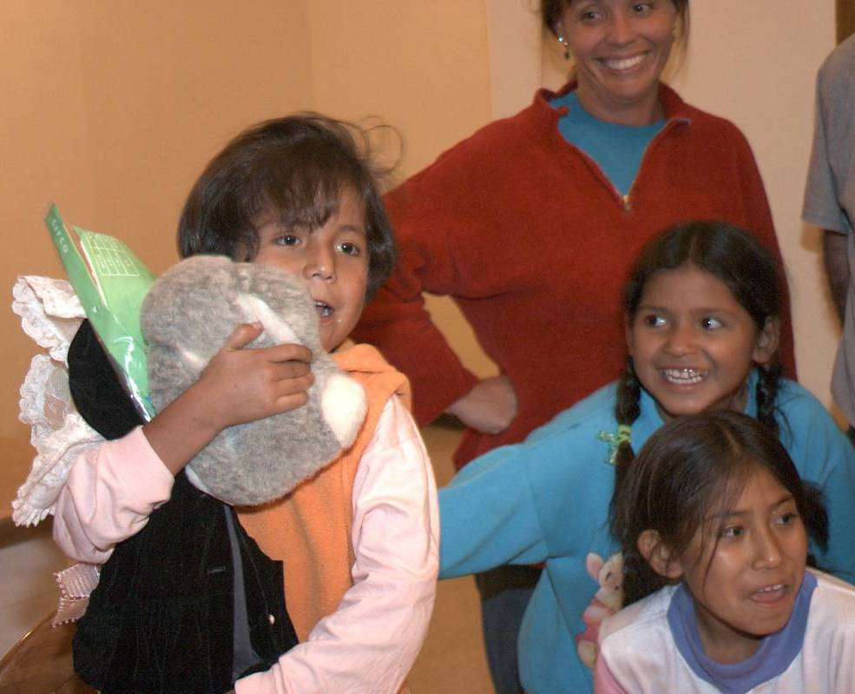
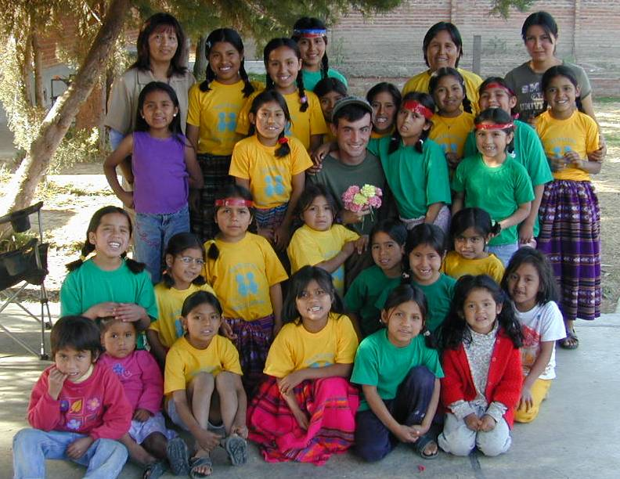
Veronica after church

